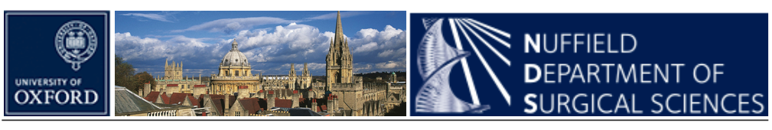

OXFORD SURGICAL SYMPOSIUM 2016 – 15TH JULY 2016

Registration of interest

Name :

Email address:

Dietary requirements :

Grade :

Hospital :

Abstract submission

Please indicate the category which best describes your work at the top of the abstract (academic, clinical, audit). Abstracts must consist of four paragraphs, entitled: Introduction and aims, methods, results and conclusions. Abstracts are to be submitted as texts and tables only (i.e. no figures, graphs or diagrams). The maximum word count is 250.

Abstracts for the Surgical Case Presentation (medical students only) should be about an interesting surgical case that had multidisciplinary involvement. Abstracts should be a maximum 250 words.

Category (delete as appropriate) : Clinical/ Academic/ Audit / Case Presentation

Title:

Authors :

Hospital :

Abstract :

