**NDS FIRE LOG BOOK**

**AND**

**EVACUATION STRATEGY**

**CONTENTS**

Introduction ……………………………………………………………………..

Ward Department Details ……………………………………………………..

Contact Numbers ………………………………………………………………

1. Floor Plans ……………………………………………………………….
2. Staff Fire Procedures …………………………………………………...
3. Department Evacuation Plan…………………………………………...
4. Provision and Maintenance of Means of Escape and Other Fire Safety Provisions ………………………………………………………..
5. Guidance to your Fire Safety Risk Assessment………………………………………………………………
6. Fire Safety Training and Departmental Record ……………………...
7. Fire Safety Policy ………………………………………………………..

**Introduction**

**Fire Log Book**

The purpose of the fire Log Book is to provide documentation detailing the precautions in place to prevent fire, and the actions to take in the event of a fire for the occupants of the ward/department it relates to.

The Log Book details the duties of ward/department managers required for the maintenance and upkeep of an adequate level of fire protection, training and evacuation strategies.

Included in the Log Book is a Fire Safety Detectors Record to record any faults identified.

The correct use and upkeep of the fire Log Book is the responsibility of the person in charge and is essential in providing documented evidence of ongoing fire precautions within the ward/department. Such a person is usually given the role of Departmental Fire Officer.

All existing and any new members of the NDS should attend a Fire Lecture provided by either the Departmental Fire Officer (DFO) or the Departmental Safety Officer (DSO) once a year so this Log Book is used only as informative and guidance purpose only. A copy of this document should therefore be given to all new members of staff or students during their probation.

**Ward/Department details**

Address: Nuffield Department of Surgical Sciences (NDS)

**NDS Fire Officer**: Jessica Doondeea

Telephone: 01865 612267

**Deputy**: Adam Lambert (DSO)

Telephone: 01865 612282

Department Head: Professor Freddie Hamdy

**Contact Numbers**

**Emergency**

**4444**

This number can be also found on the back of any OUH identification car. Remember to state clearly the location and site of the fire, repeating the information if necessary. Do not put the phone down until you are sure that all relevant information has been given.

**Routine Fire Enquiry**

**Fire Safety Department**

The Estates Department

The Churchill Hospital

Oxford

OX3 7LE

Tel: 01865 225483

**For faults or Defects in any Fire Safety Equipment**

**Help Desk**

JRI, JRII, Churchill Hospital, Horton Hospital **20600**

**Help Desk**

West Wing **40404**

Churchill PFI **35353**

1. **FLOOR PLANS**
   1. **JR II Level 5**

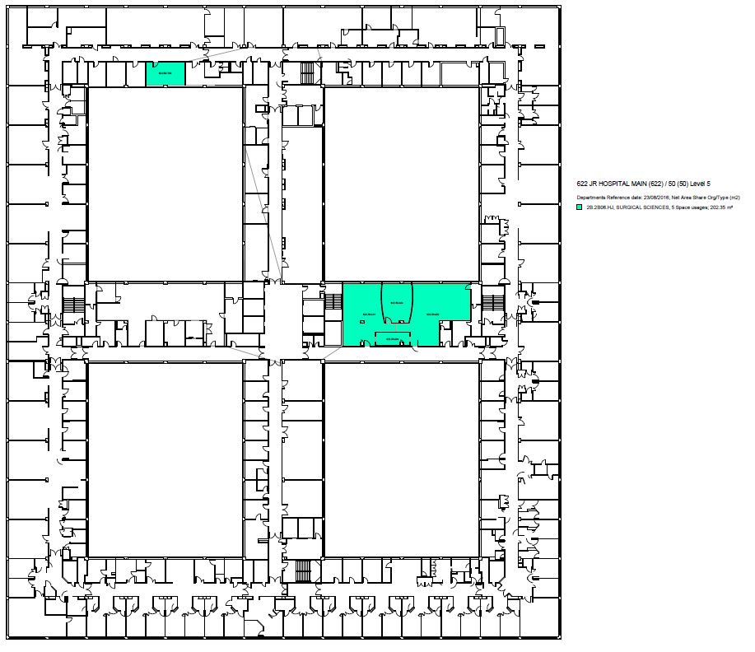

* 1. **JR II Level 6**

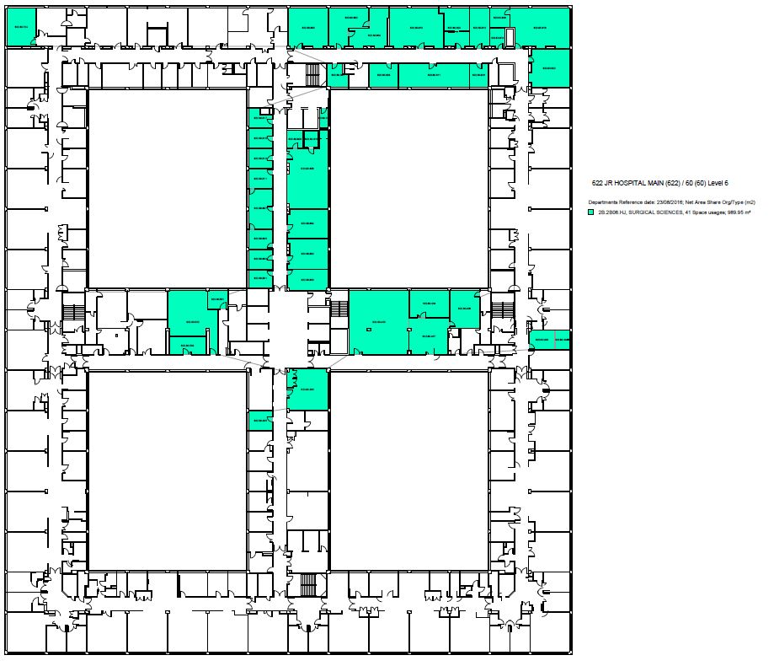

* 1. **JRII West Wing Level 6**

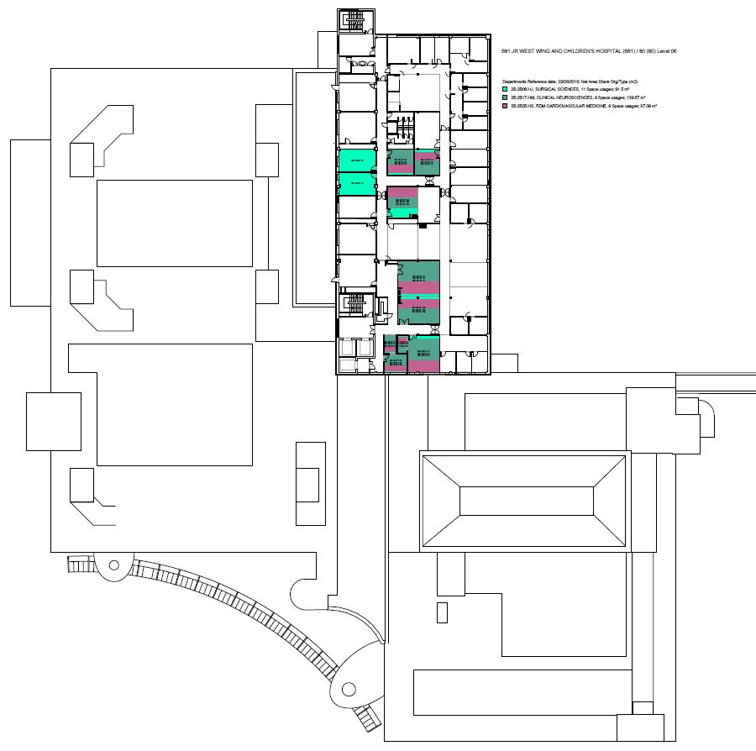

* 1. **Churchill Hospital OCDEM**

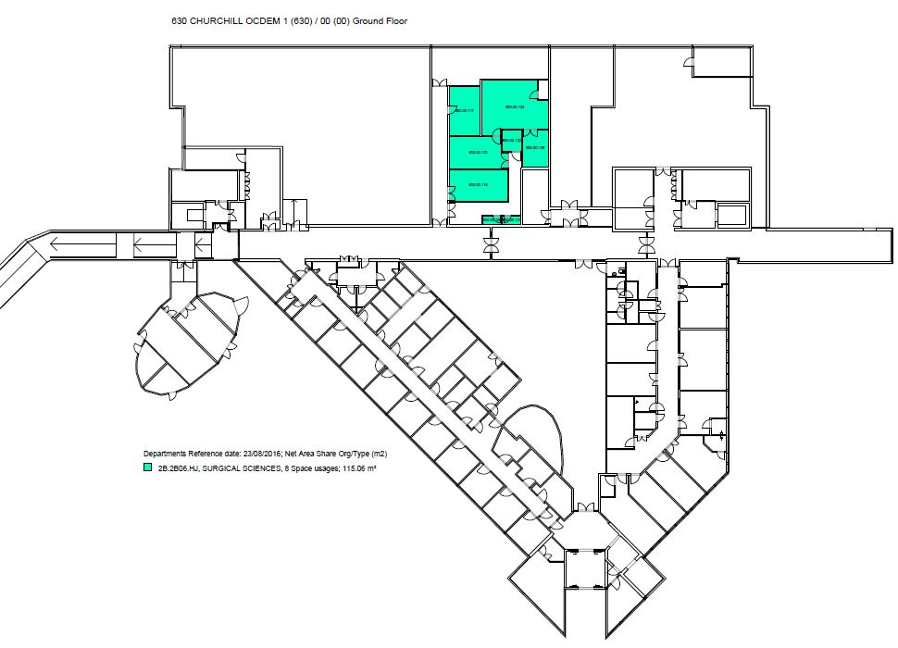

1. **Staff Fire Procedures**

|  |
| --- |
| **2.1 Actions on Discovering a Fire/Strongly Suspecting a Fire** |

1. Raise the alarm by activating the nearest break glass call point.
2. Dial 4444 and give details of fire and exact location.
3. Consider evacuating the building horizontally to an adjacent safe area as per your department evacuation plan.
4. **DO NOT** attempt to fight the fire unless it is safe to do so.

|  |
| --- |
| **2.2 What to do when the Fire Alarm sounds intermittently** |

**Prepare for possible evacuation in the time available.**

The person in charge of the ward or department should ensure the following tasks are undertaken:

1. Send someone to find out why the fire alarm has gone off.
2. Shut all doors and windows
3. Account for all patients and staff
4. Ascertain who needs assistance
5. Inform/reassure visitors
6. Prepare and check escape routes

|  |
| --- |
| **2.3 What to do when Fire Alarm sounds continuously** |

1. With caution, briefly investigate to try to establish the reason for the alarm.
2. If you are **absolutely certain** that the activation of the fire alarm is a **FALSE ALARM** and poses **NO RISK, call 4444** and advice switchboard that the Fire Brigade is not required.
3. If it is a **FIRE call** 4444 **immediately** and give location of fire.
4. Prepare to evacuate following the Department evacuation plan.
5. Move those in immediate danger first, then ambulant and the non-ambulant.
6. **ONLY** if it is safe to do so, consider using the first aid firefighting equipment to put the fire out. Do not put yourself at risk.
7. Use the Ward/Department evacuation plan if evacuation required.
8. Do not use lifts within the area that the continuous alarm can be heard in.

**2.4 Vertical Evacuation to a Lower Floor**

1. Person in charge identifies destination of evacuation that is to the best knowledge available “a place of reasonable safety” utilising Department Evacuation Plan.
2. Commence vertical evacuation using the Department Fire Evacuation Plan that you have been trained with and follow the detailed steps in the plan.
3. **Department Evacuation Plan**

The departmental evacuation plan is detailed below.

If there is an intermittent fire alarm then evacuation is not necessary.

However, be aware that there is a potential fire in the adjacent fire section and be prepared to evacuate if necessary.

If the fire alarm is/becomes constant then evacuation is necessary for all staff/visitors within the department.

As the building is a hospital there are certain issues regarding evacuation of patients. The Trust policy is that the evacuation is primarily a horizontal one. Bearing this in mind, in order to make that process easier for Trust staff and patients, our departmental policy states that staff evacuates vertically. This allows any horizontal space to be given over to patients.

1. **Provision and Maintenance of Means of Escape and other Fire Safety provisions**

**Please note that whilst the above is the responsibility of the Trust it is every individual’s responsibility to report any defects in the provisions set out below. This should be done through the Estates helpdesk Tel. 20600 or by informing the Departmental Fire Officer (currently Jakub Kupinski) who will inform the relative Trust Department.**

* 1. **Means of Escape**

Means of escape related to all fire doors, corridors, clearways, stairways and fire exits. These all have essential parts to play in the means of escape in the event of a fire. Escape routes are indicated on the plan.

Property Services have an ongoing programme of planned preventative maintenance. However, it is the responsibility of the person in charge of the ward/department to ensure that the following points are complied with. Any defects noted should be reported to Property Services and noted on Fire Safety Provisions Defect Record.

* Escape routes must be kept clear and free from obstructions at all times.
* Stair wells must be kept clear at all times and not used to store equipment/supplies.
* Floors and floor coverings, particularly on staircases, must be maintained in good order at all times.
* Fire resisting self-closing doors must be maintained in effective working order and must be kept closed unless held open on an automatic release system which is activated by the fire alarm system. Wedges of any description are not to be used.
* All doors providing a means of escape from the premises to an outside area (Fire Exits) must be maintained easily openable and ready for use at all times.
* Fire exit and other signs must be maintained in good order and must be clearly visible at all times.
* All break glass all points must be easily accessible at all times.
* Emergency door fastenings (Panic bolts, glass locks) where fitted should be examined weekly.

**4.2 Emergency Lighting**

**Emergency Lighting is provided.**

Property Services Department and Contracted Engineers are responsible for ensuring that the emergency lighting system is in full working order by energising all luminaries for a short period by simulating mains failure. During power failures wards/departments should examine emergency lights to ensure they are working and any defects noted and reported immediately to the Property Services Department and noted on Fire Safety Provisions Defect Record.

**4.3 Fire Alarm System**

A fire alarm system is provided.

Tests/inspections will be carried out on the fire alarm system on a weekly, quarterly and annual basis by Property Services Department and Contracted Fire Alarm engineers. The weekly test will take place at the same time each week to avoid confusion. Any defects noted by staff during these tests should be reported immediately you Property Services Department and noted on Fire Safety Provisions Defect Record.

**4.4 Fire Fighting Equipment**

Fire Fighting Equipment is provided.

Inspection and maintenance of extinguishers, including period discharge of all stored pressure and gas cartridge extinguishers will be carried out annually. The Trust uses a method of colour coding to show those extinguishers that have received an annual test. This colour is changed each year and all staff will be informed in January of the respective years colour.

Staff should carry out a routine inspection of all hand held firefighting equipment to ensure that it is in the correct position, has not been discharged and does not show signs of damage or leakage. Any faults identified by inspection or otherwise should be reported immediately to Property Services Department and noted on Fire Safety Provisions Defect Record.

**4.5**_**Dry Risers**

Inspection and maintenance of dry risers will be carried out annually by outside contractor. Any faults identified by inspection or otherwise by staff should be reported immediately to Property Services Department and noted on Fire Safety Provisions Defect Record.

**4.6 Types of Fire Fighting Equipment**

**4.6.1 Extinguishers**

Water – Red

Carbon Dioxide (CO2) – Red with block identification sticker/markings

Foam – Red with cream identification sticker/markings

Dry powder – Red with blue identification sticker/markings

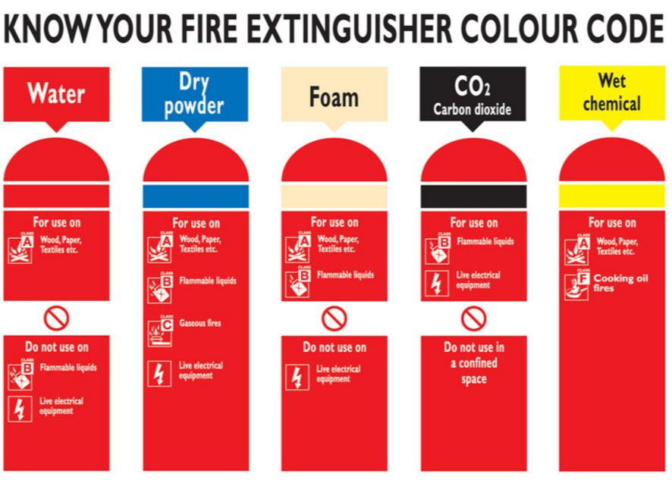

To comply with European legislation all fire extinguishers are required to be red in colour.

Extinguishers will however have colour coding stickers allowing users to identify the correct extinguishers for the type of fire they are dealing with.

**Do not put yourself at risk in attempting to tackle a fire!**

**4.6.2 Fire Blankets**

Fire blankets may be situated in kitchens or laboratory areas that represent fire hazards.

|  |
| --- |
| 1. **FIRE SAFETY RISK ASSESSMENT** |
| **1 Identify fire hazards**  Identify:  Sources of ignition  Sources of fuel  Sources of oxygen |
|  |
| **2 Identify people at risk**    Identify:  People in and around the premises  People especially at risk |
|  |
| **3 Evaluate, remove, reduce and protect from risk**    Evaluate the risk of a fire occurring  Evaluate the risk to people from fire  Remove or reduce fire hazards  Remove or reduce the risk to people   * Detection and warning * Fire-fighting * Escape routes * Lighting * Signs and notices * Maintenance |
|  |
| **4 Record, plan, inform, instruct and train**    Record significant finding and action taken  Prepare an emergency plan  Inform and instruct relevant people; co-operate and co-ordinate with others  Provide training |
|  |
| **5 Review**  Keep assessment under review  Revise where necessary |
|  |
| **Remember to keep your Fire Risk Assessment under review** |

1. **Fire Safety Training and Departmental Record**

In the event of a fire the safety of staff, patients, contractors and visitors depends heavily on the ability of staff to respond promptly to the situation.

It is of vital importance that all members of staff are provided with adequate information, instruction and training so that they understand the fire precautions applicable to the building and the action to be taken in the event of a fire (or the fire alarm being activated).

All staff should receive instruction and training as per the Fire Safety Policy appropriate to their responsibilities in the event of an emergency (fire) therefore **attendance once a year on the NDS Fire Lecture is mandatory for all staff.** All Fire Lecture attendees must sign the register otherwise their training may need to be repeated.

Annual instruction and training for staff should cover the following general matters:

* The action to be taken on discovering a fire.
* The action to be taken on hearing the fire alarm.
* Raising the alarm/location of call points and control panels.
* The correct method of calling the Fire Service.
* Knowledge of escape routes.
* The importance of fire doors/precautions to minimise the spread of smoke and flames.
* The location and use of firefighting equipment.

Notices stating concise actions to be taken in the event of a fire/or on hearing the fire alarm are displayed at conspicuous points throughout the premises.

1. **Fire Safety Policy**

Further guidance can be found in the Fire Safety Policy. Hard copy is displayed on the wall in the NDS office located on Level 5, JR II but a hard copy can also be obtained from the HR office, JR II, Level 6. An electronic copy can be obtained from:

(Y:) Administration (\\TIBIA1\SURGERY)/ndsadmin/health and safety/Fire Safety/Fire Policy Local Rules for Nuffield Department of Surgical Sciences v3.0 24032017.doc