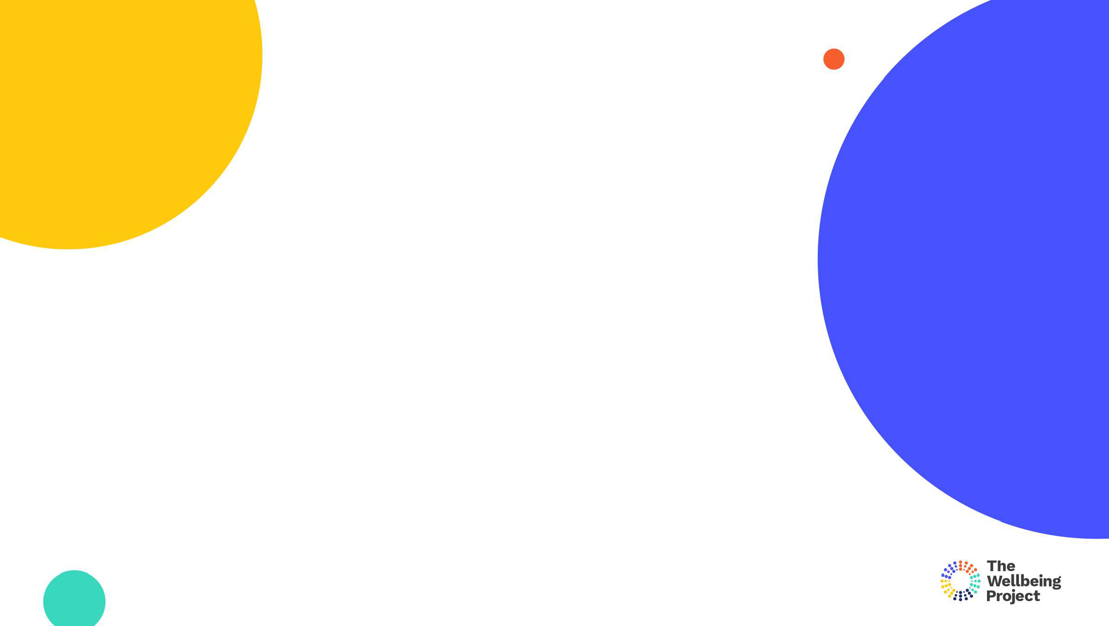

Resilience

* To overcome or move on from unpleasant experiences which could ‘over-shadow’ our future
* To steer through everyday adversities, stress and challenges
* To recover from major setbacks or trauma
* To grow from experience

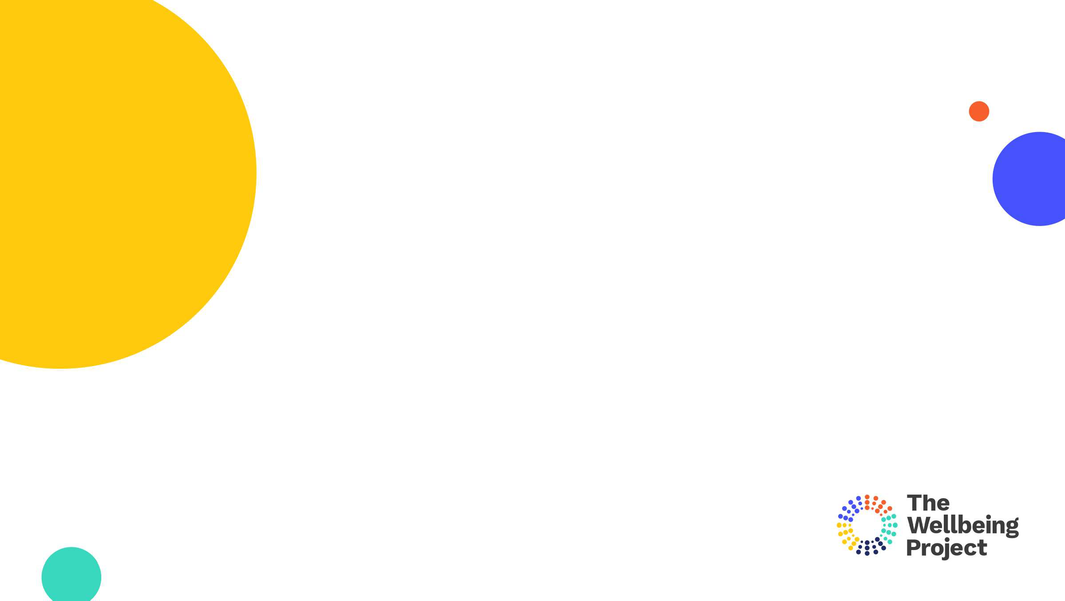

Resilience Espresso

Copyright The Wellbeing Project 2021

1

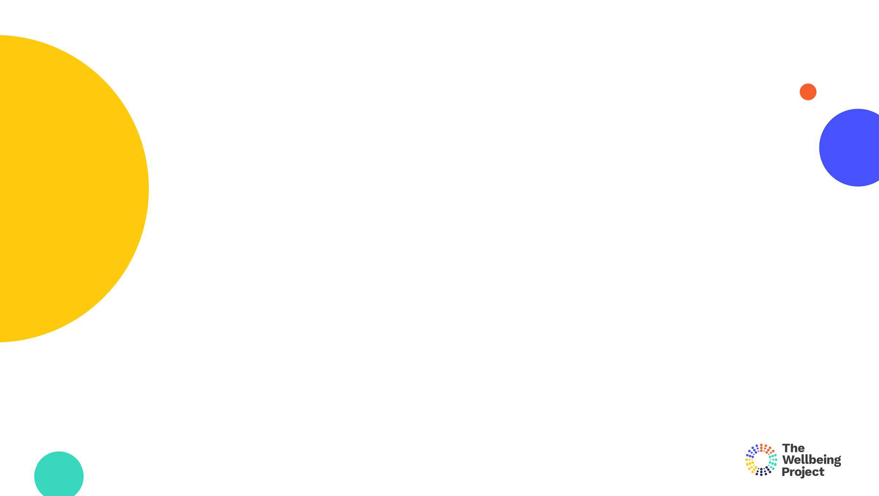

1.

Understanding resilience

3

Copyright The Wellbeing Project 2021

3

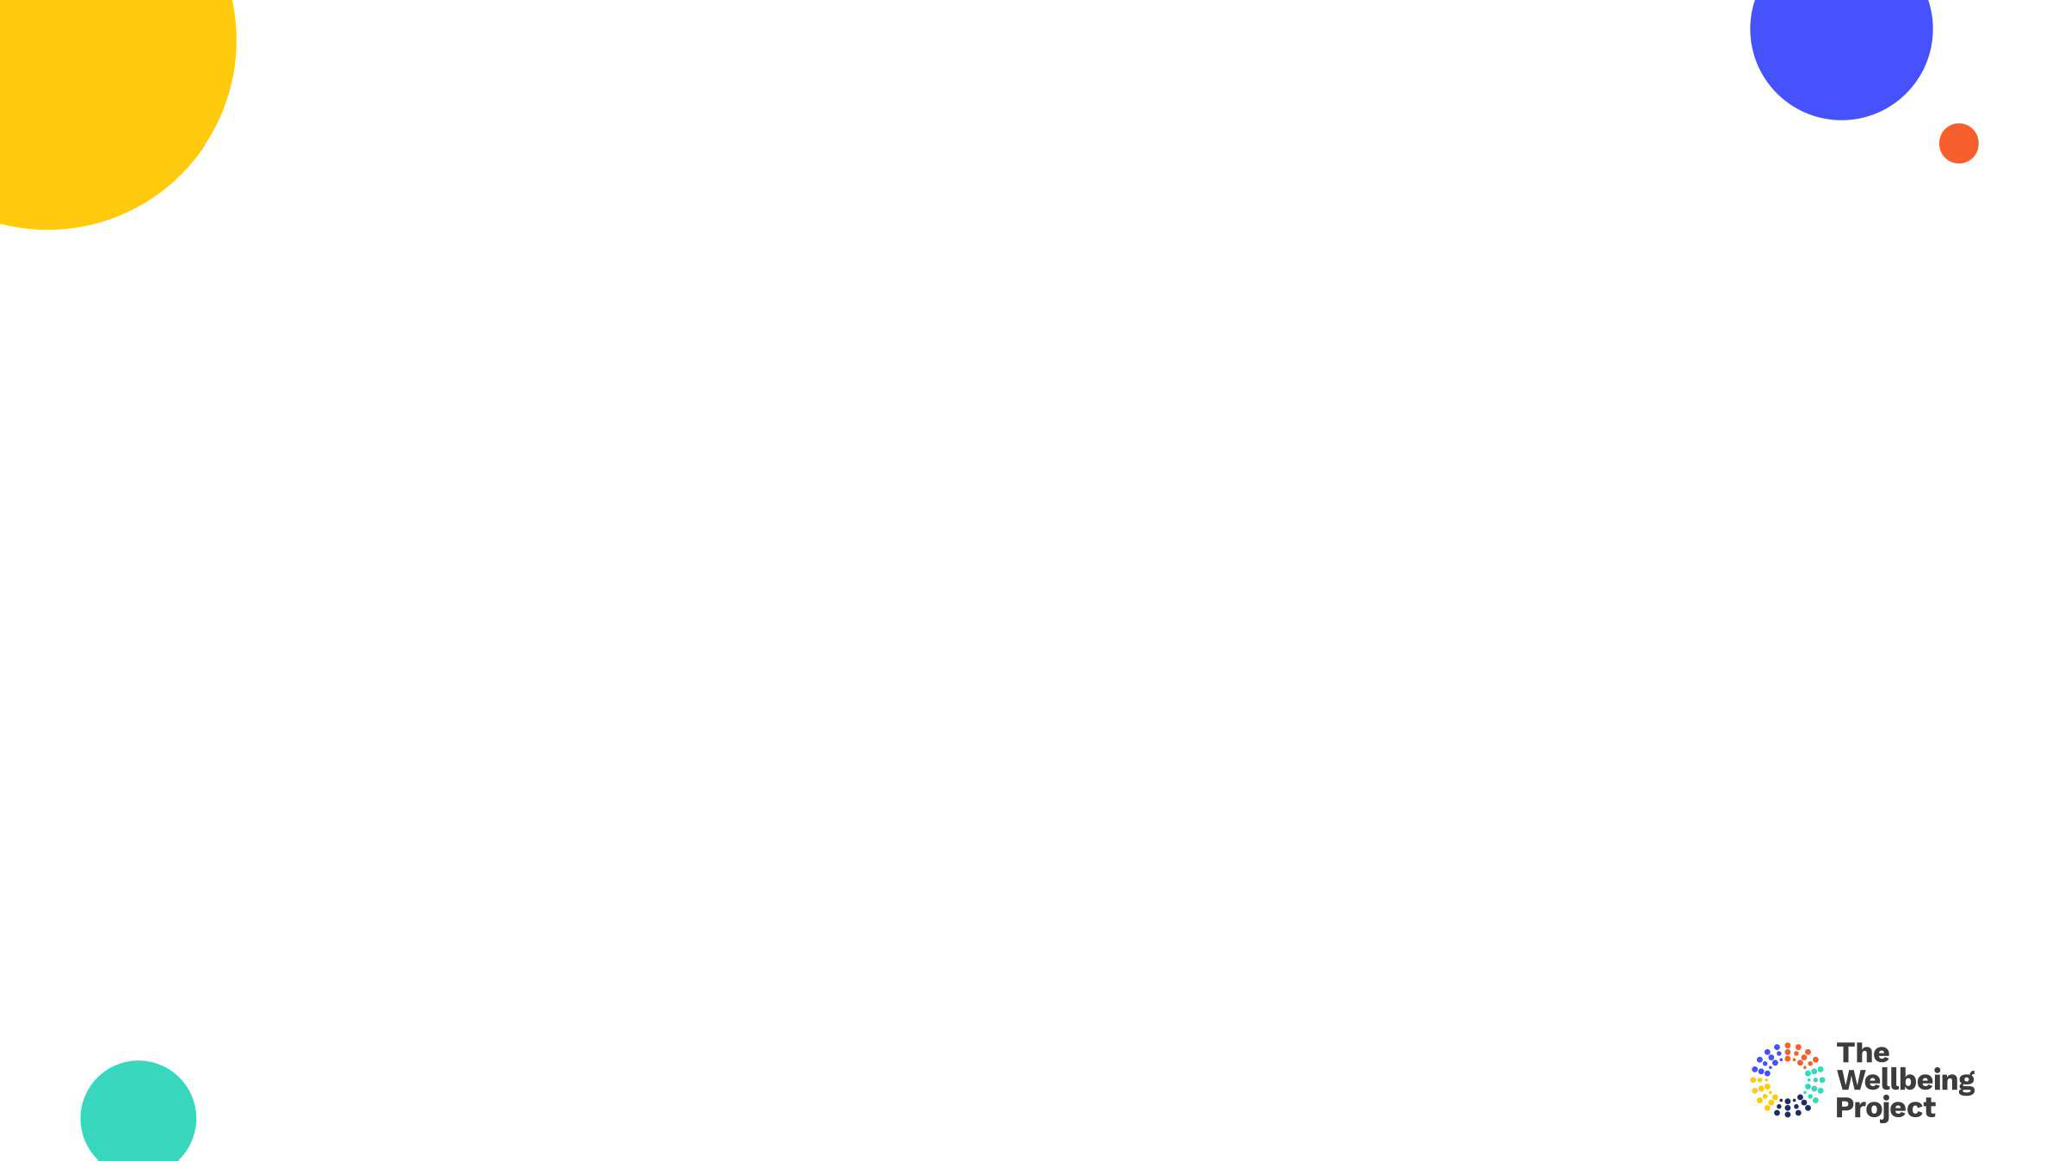

**Energy** Sustaining and renewing physical energy to have the capacity to keep going through challenging times.

**Future focus** Having a clear sense of purpose and direction to help to move forwards without getting stuck or feeling held back.

**Inner drive**

Sustaining self belief when times get tough, displaying confidence, motivation and perseverance.

**Flexible thinking** Having an open and optimistic mindset, enabling a positive and adaptive response to change and challenges.

**Strong relationships** Building open and trusting relationships, and being willing to

call on these for help and support if facing a challenge.

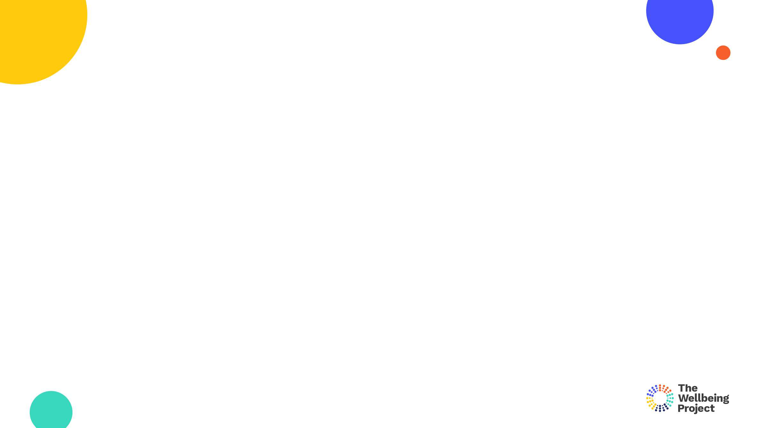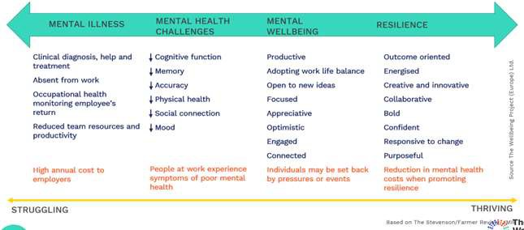

Workplace resilience and wellbeing

Copyright The Wellbeing Project 2021

5

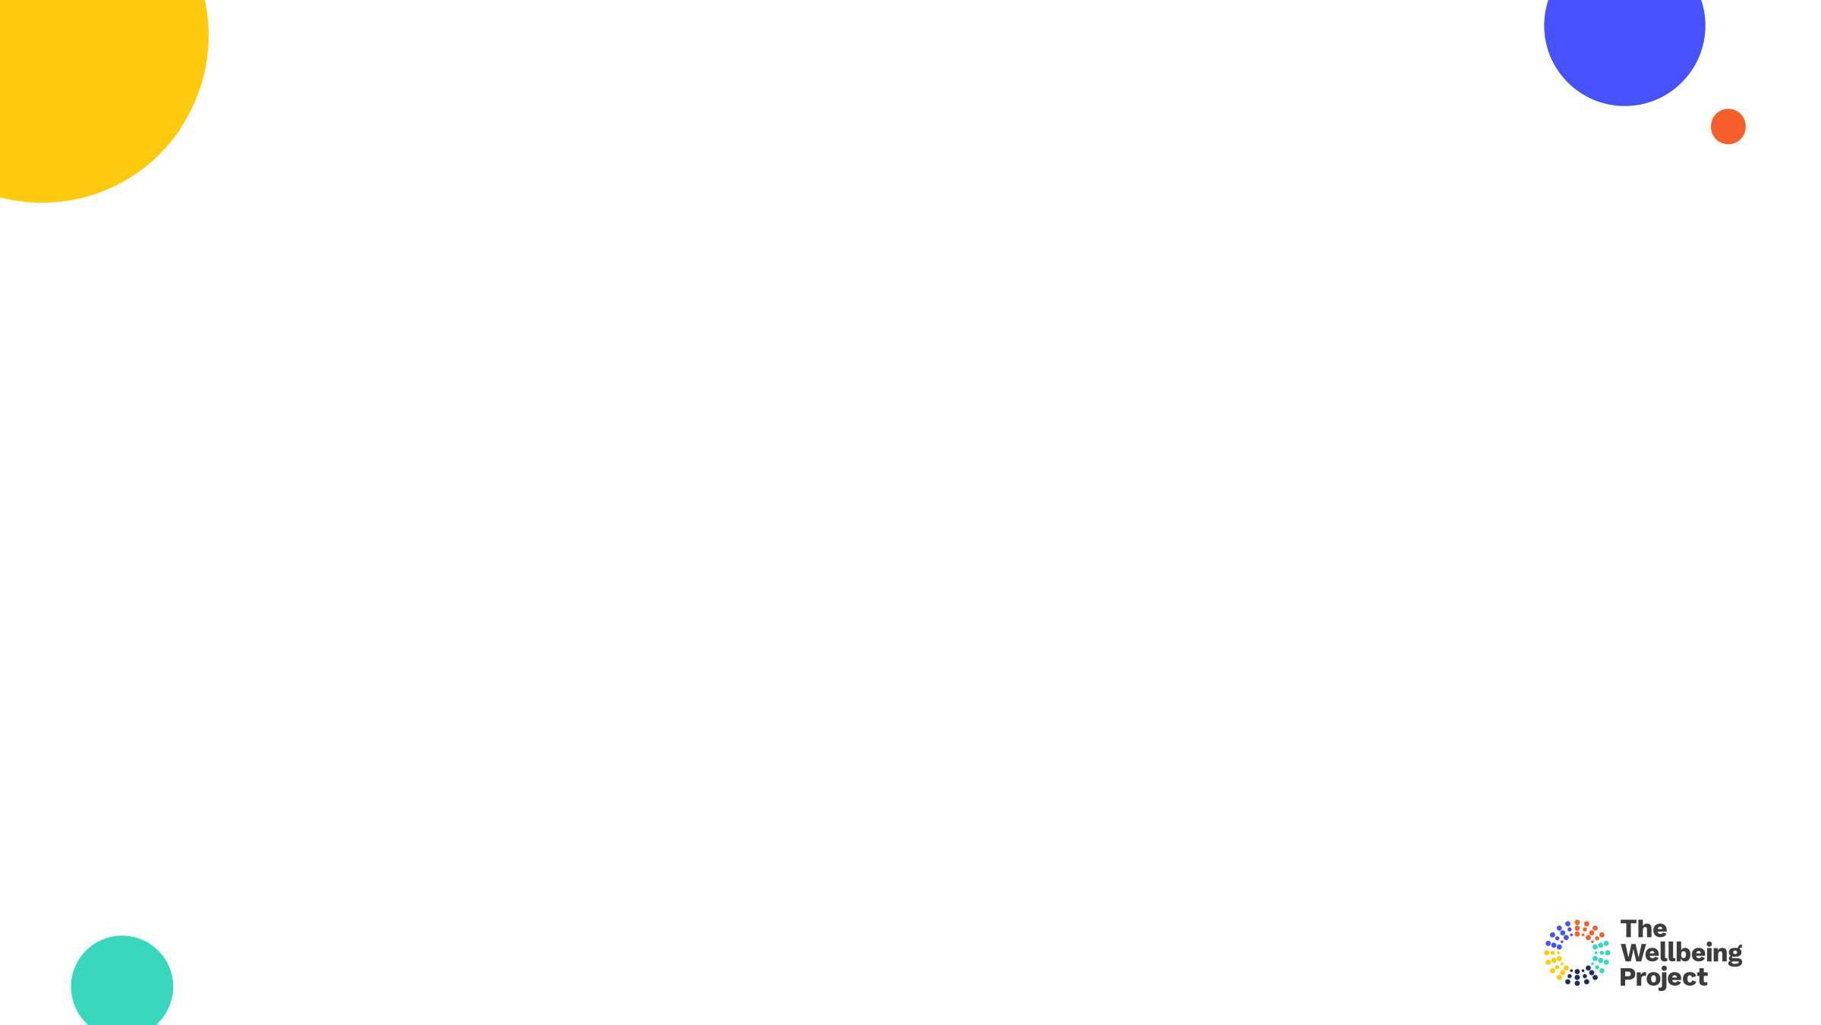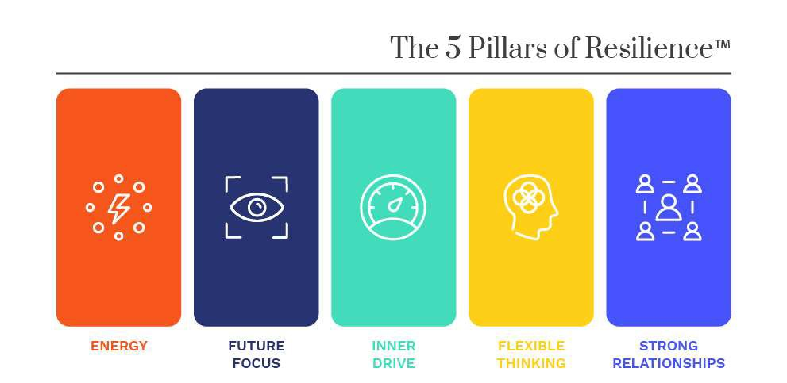

Copyright The Wellbeing Project 2021

6

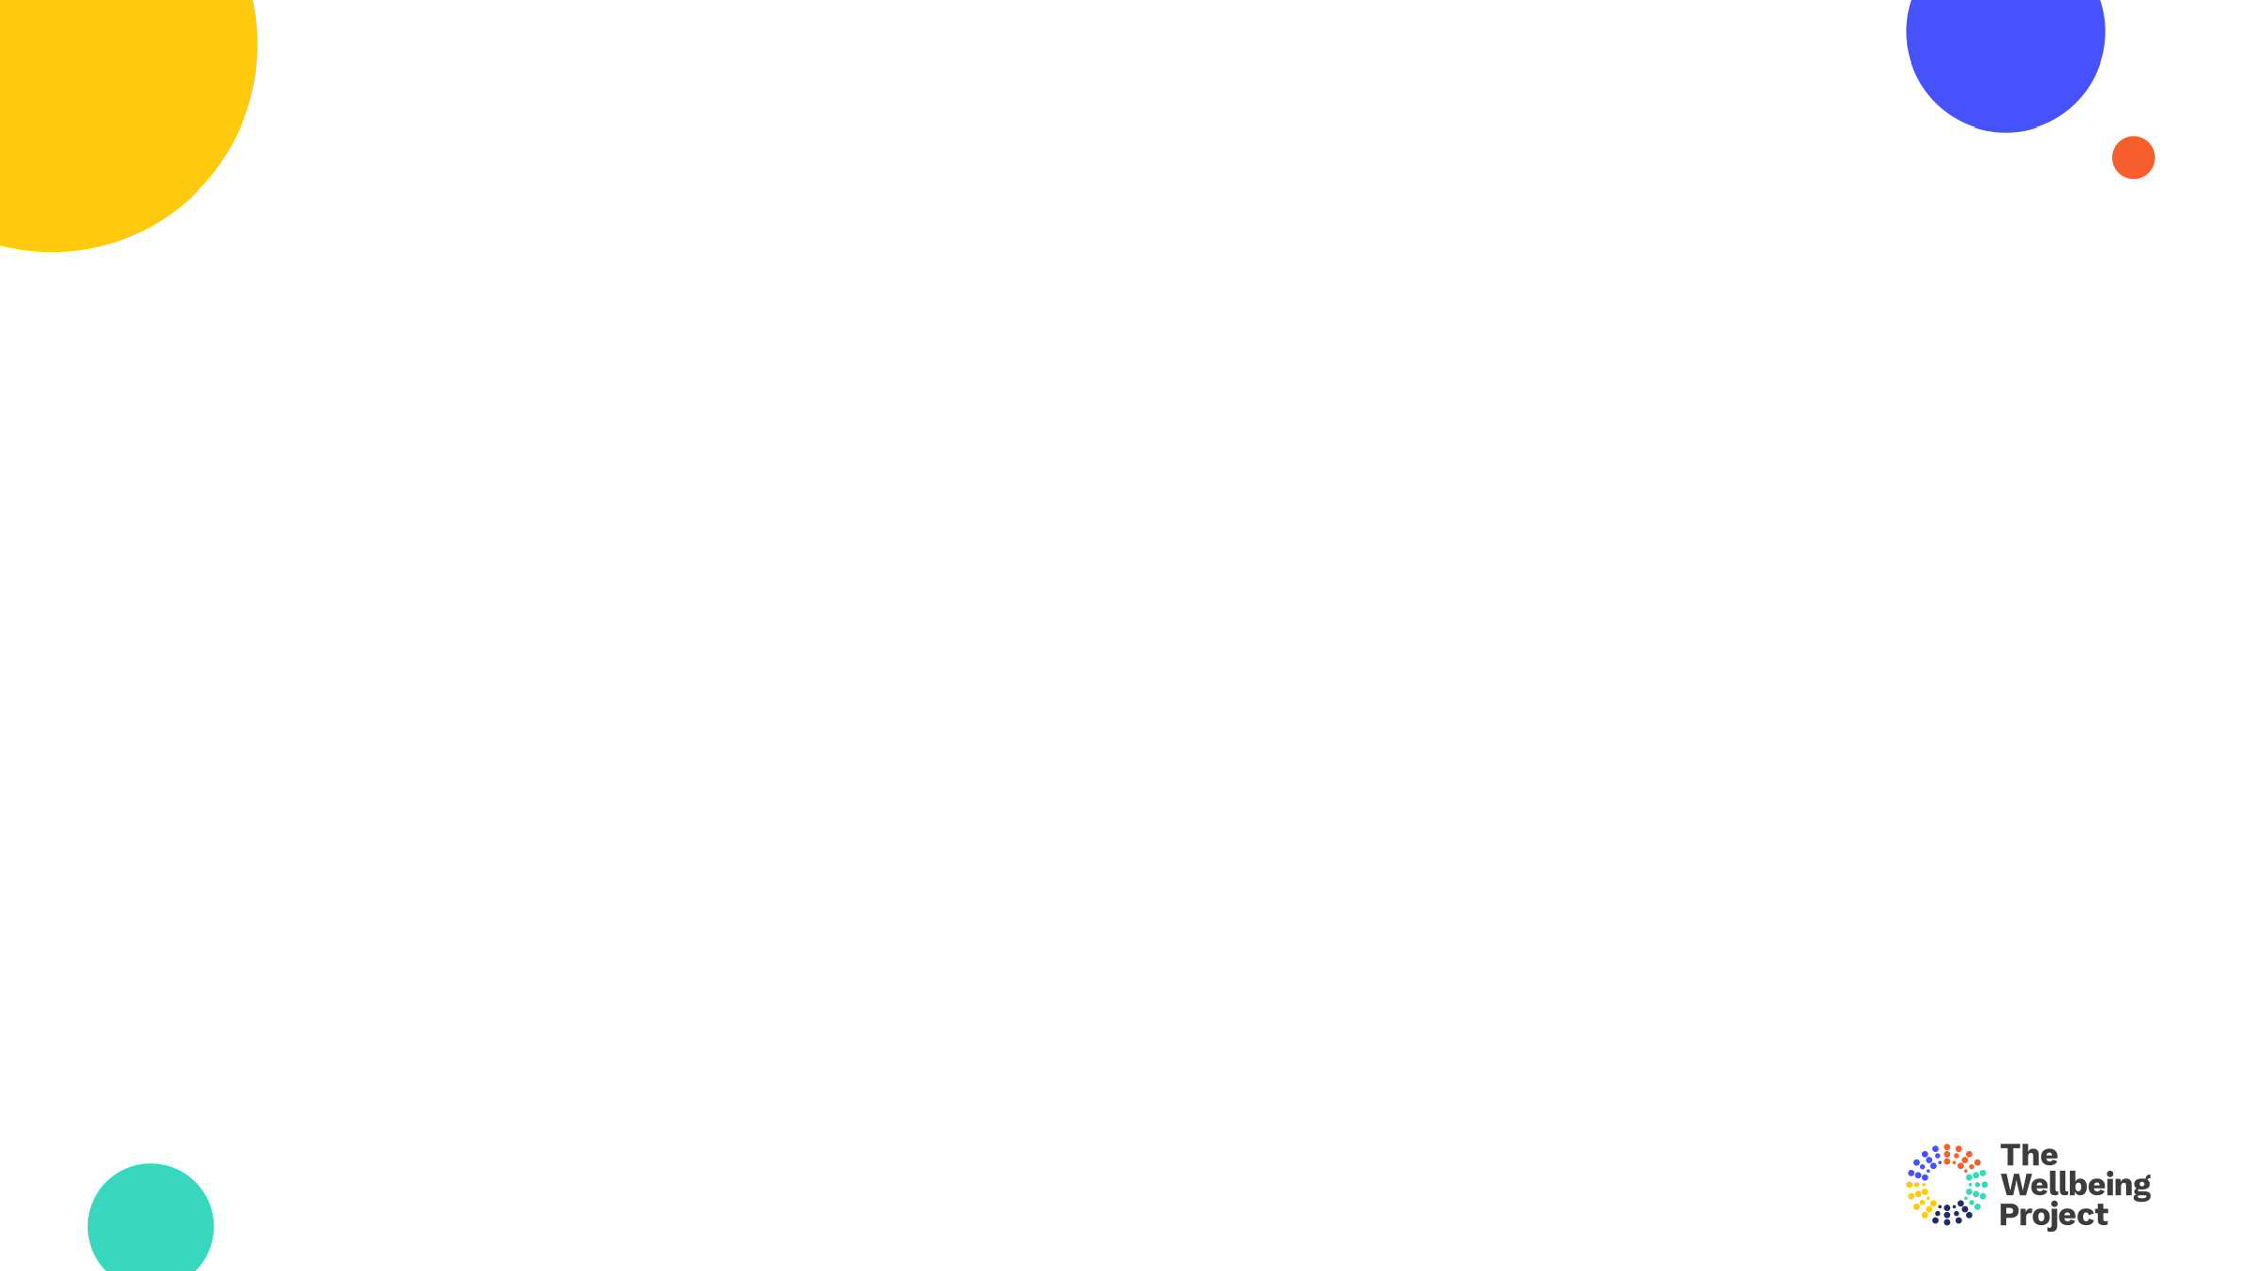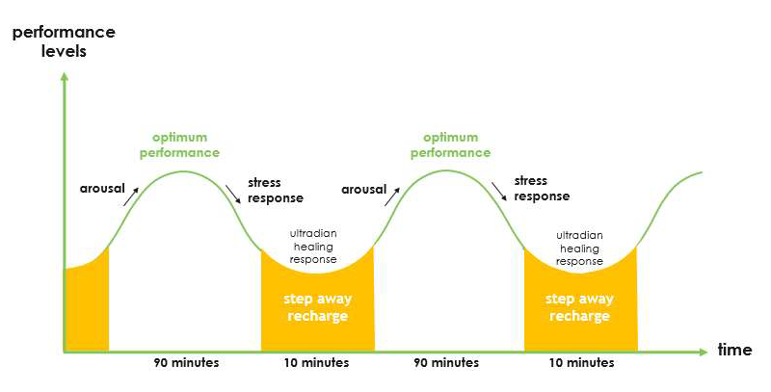

The ultradian rhythm



2. Energy

Copyright The Wellbeing Project 2021

8

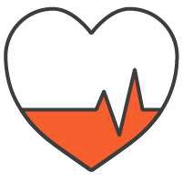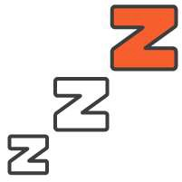

Boundaries Physical activity

Sleep

Healthy consumption

Copyright The Wellbeing Project 2021

9

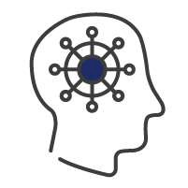

Purpose Personal control

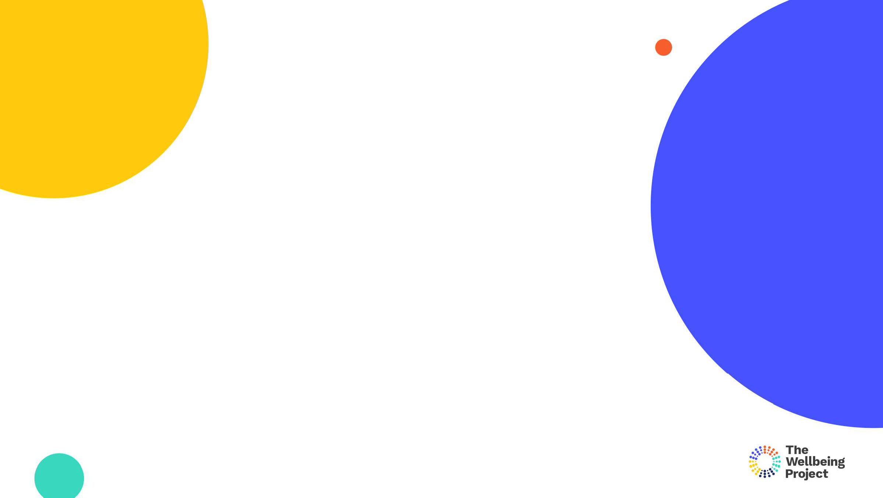

Energy management

What small changes could you make to your day to ensure adequate rest?

* Regular breaks
* Workspace
* Time for meals and exercise
* Time to rest and recharge?

Copyright The Wellbeing Project 2021

11



3. Future focus

12 Copyright The Wellbeing Project 2021

12

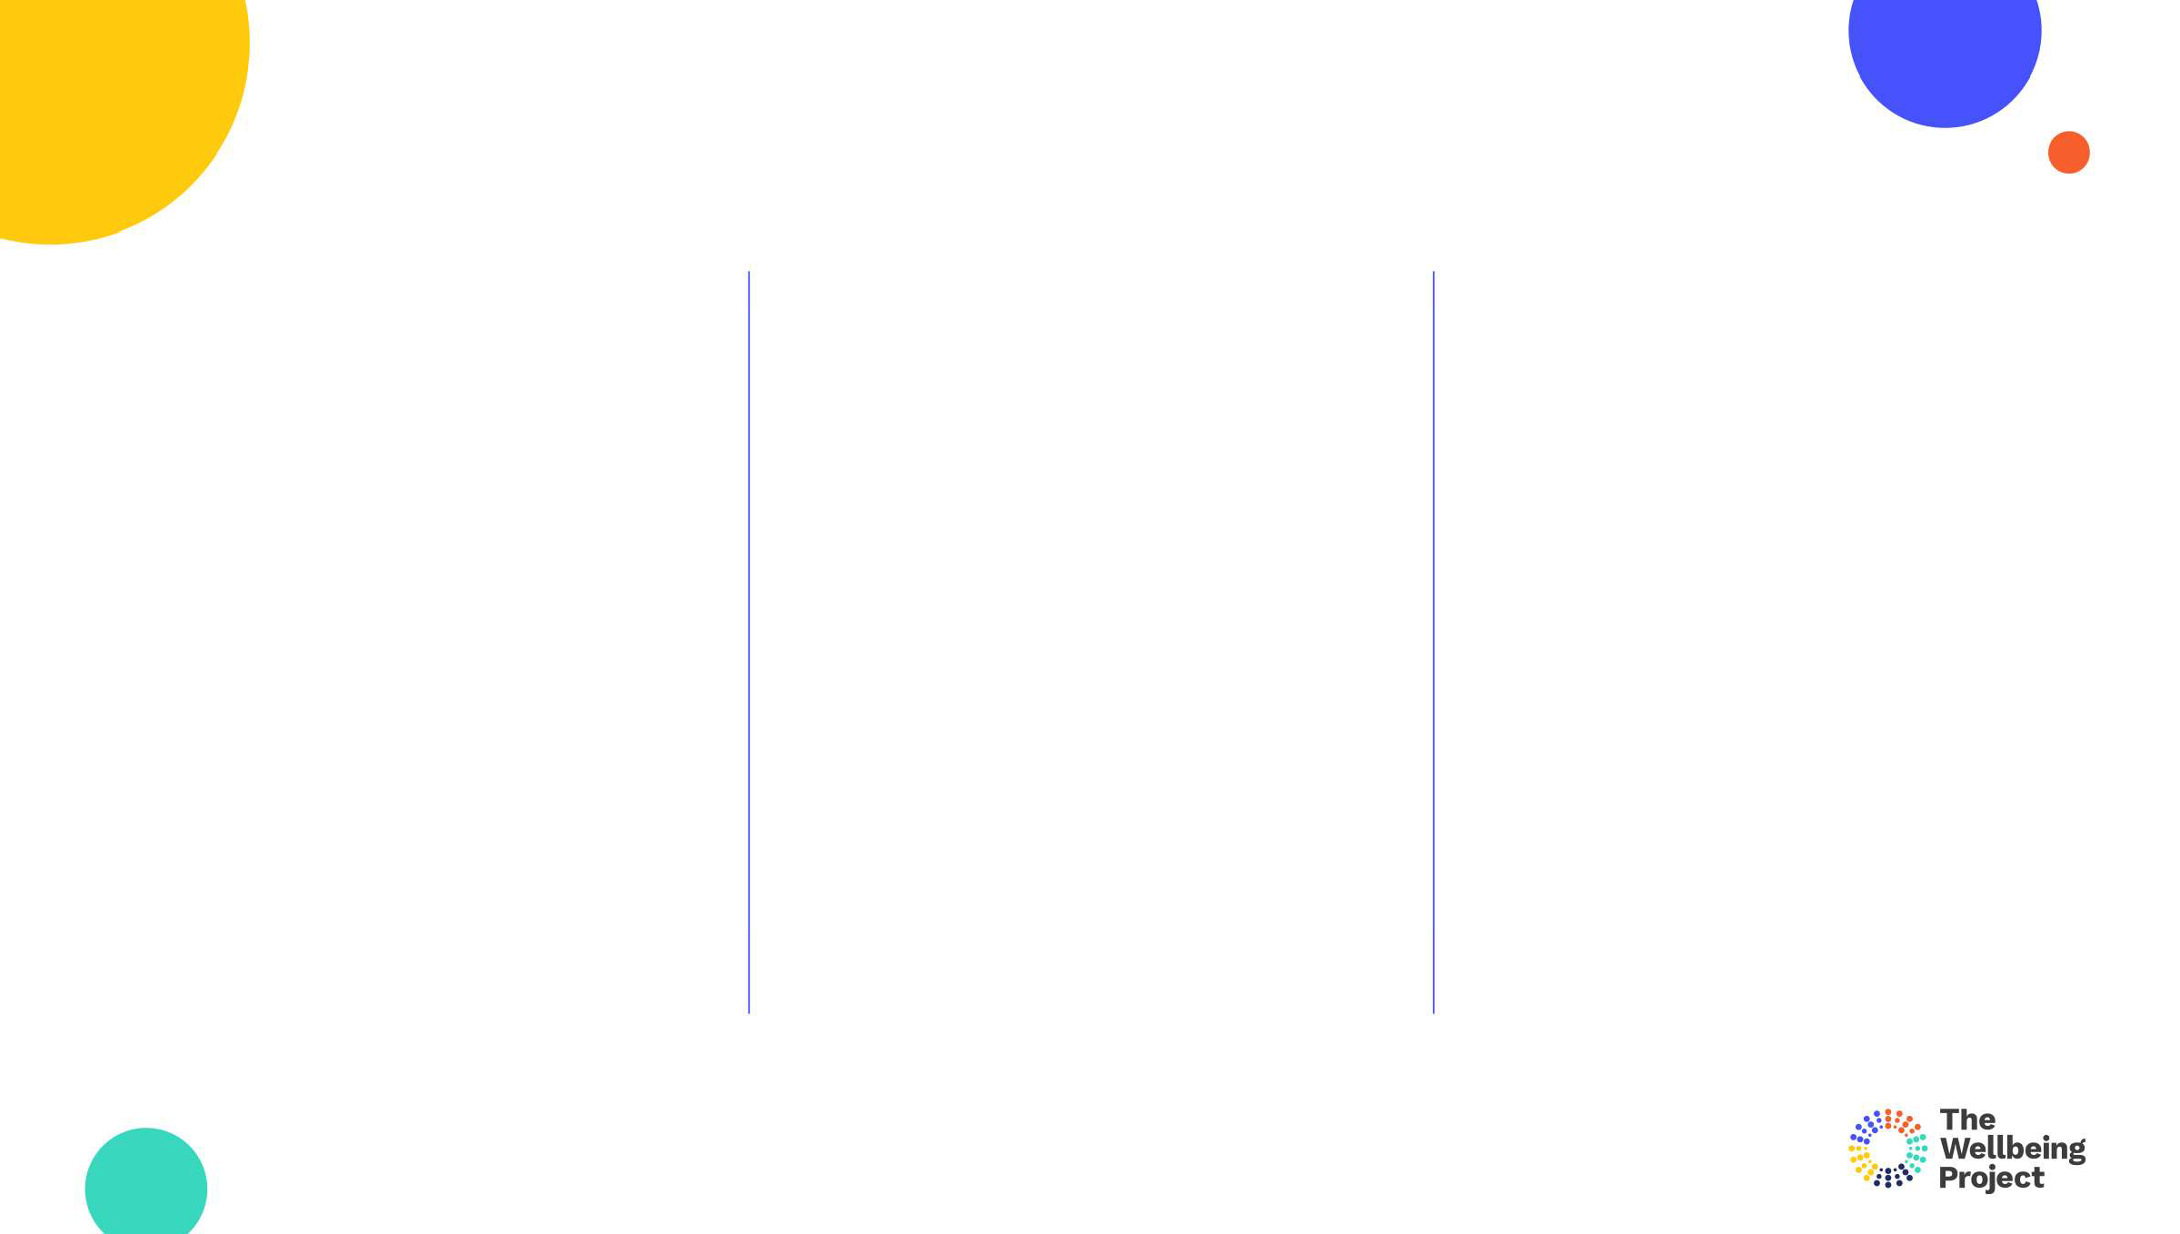

Present reality

* What is the current reality?
* What feelings arise?

14

Copyright The Wellbeing Project 2021

14



Present reality

Desired future

* What is the current reality?
* What feelings arise?
* How will it look?
* How will it sound?
* How will it feel?
* What will you be doing?
* What will be different?

15

Copyright The Wellbeing Project 2021

15

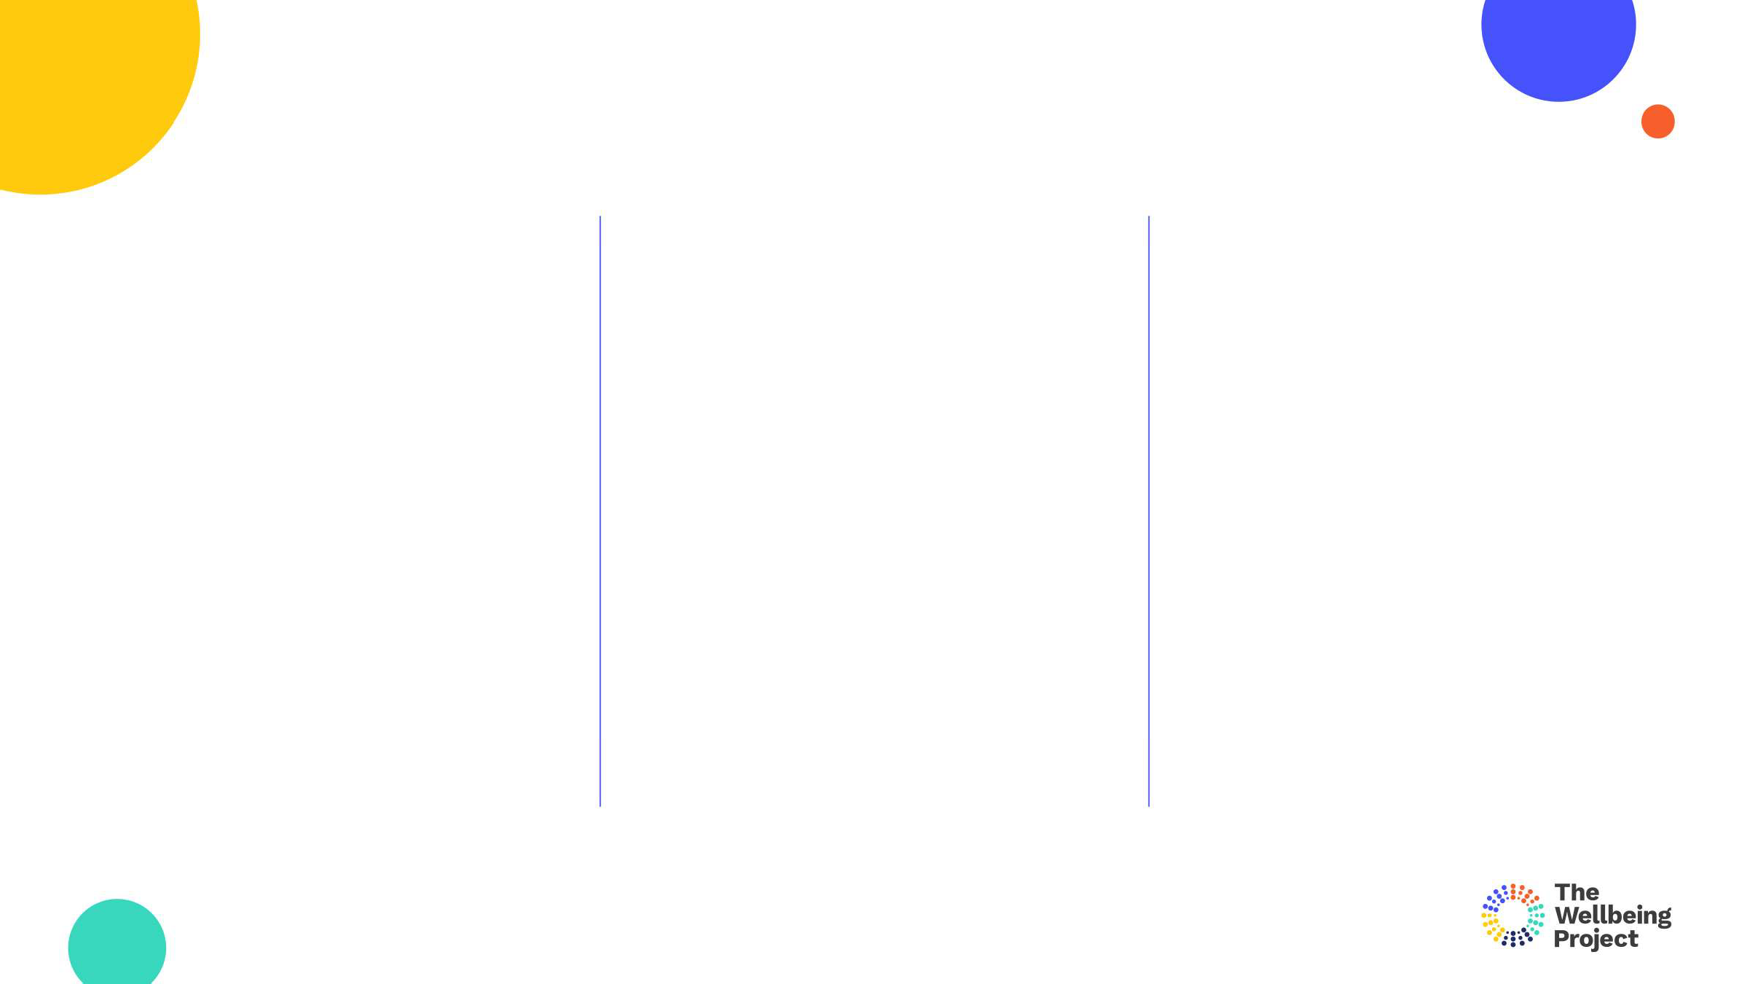

Present reality

Pathway / Steps

Desired future

* What is the current reality?
* What feelings arise?
* How did you get there?
* What actions did you take?
* What behaviours did you change?
* What support did you ask for?
* How will it look?
* How will it sound?
* How will it feel?
* What will you be doing?
* What will be different?

16

Copyright The Wellbeing Project 2021



The grit interview

* What did you have to do to accomplish that goal?
* Did you ever think of giving up?
* If so, how did you overcome that?
* How did you feel when you accomplished that goal?
* What did you learn that will support you to achieve your future goals?



4. Inner drive

17 Copyright The Wellbeing Project 2021

17

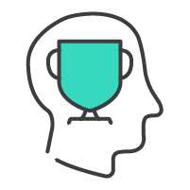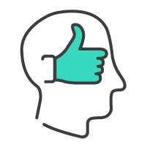

Motivation

Self-belief

Copyright The Wellbeing Project 2021

18

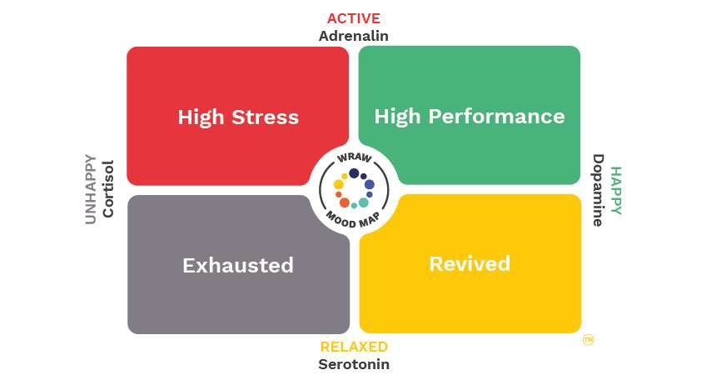

5.

Aspects of flexible thinking

20

Copyright The Wellbeing Project 2021

20

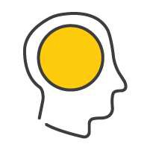

Open mindedness

Positive framing

Copyright The Wellbeing Project 2021

21

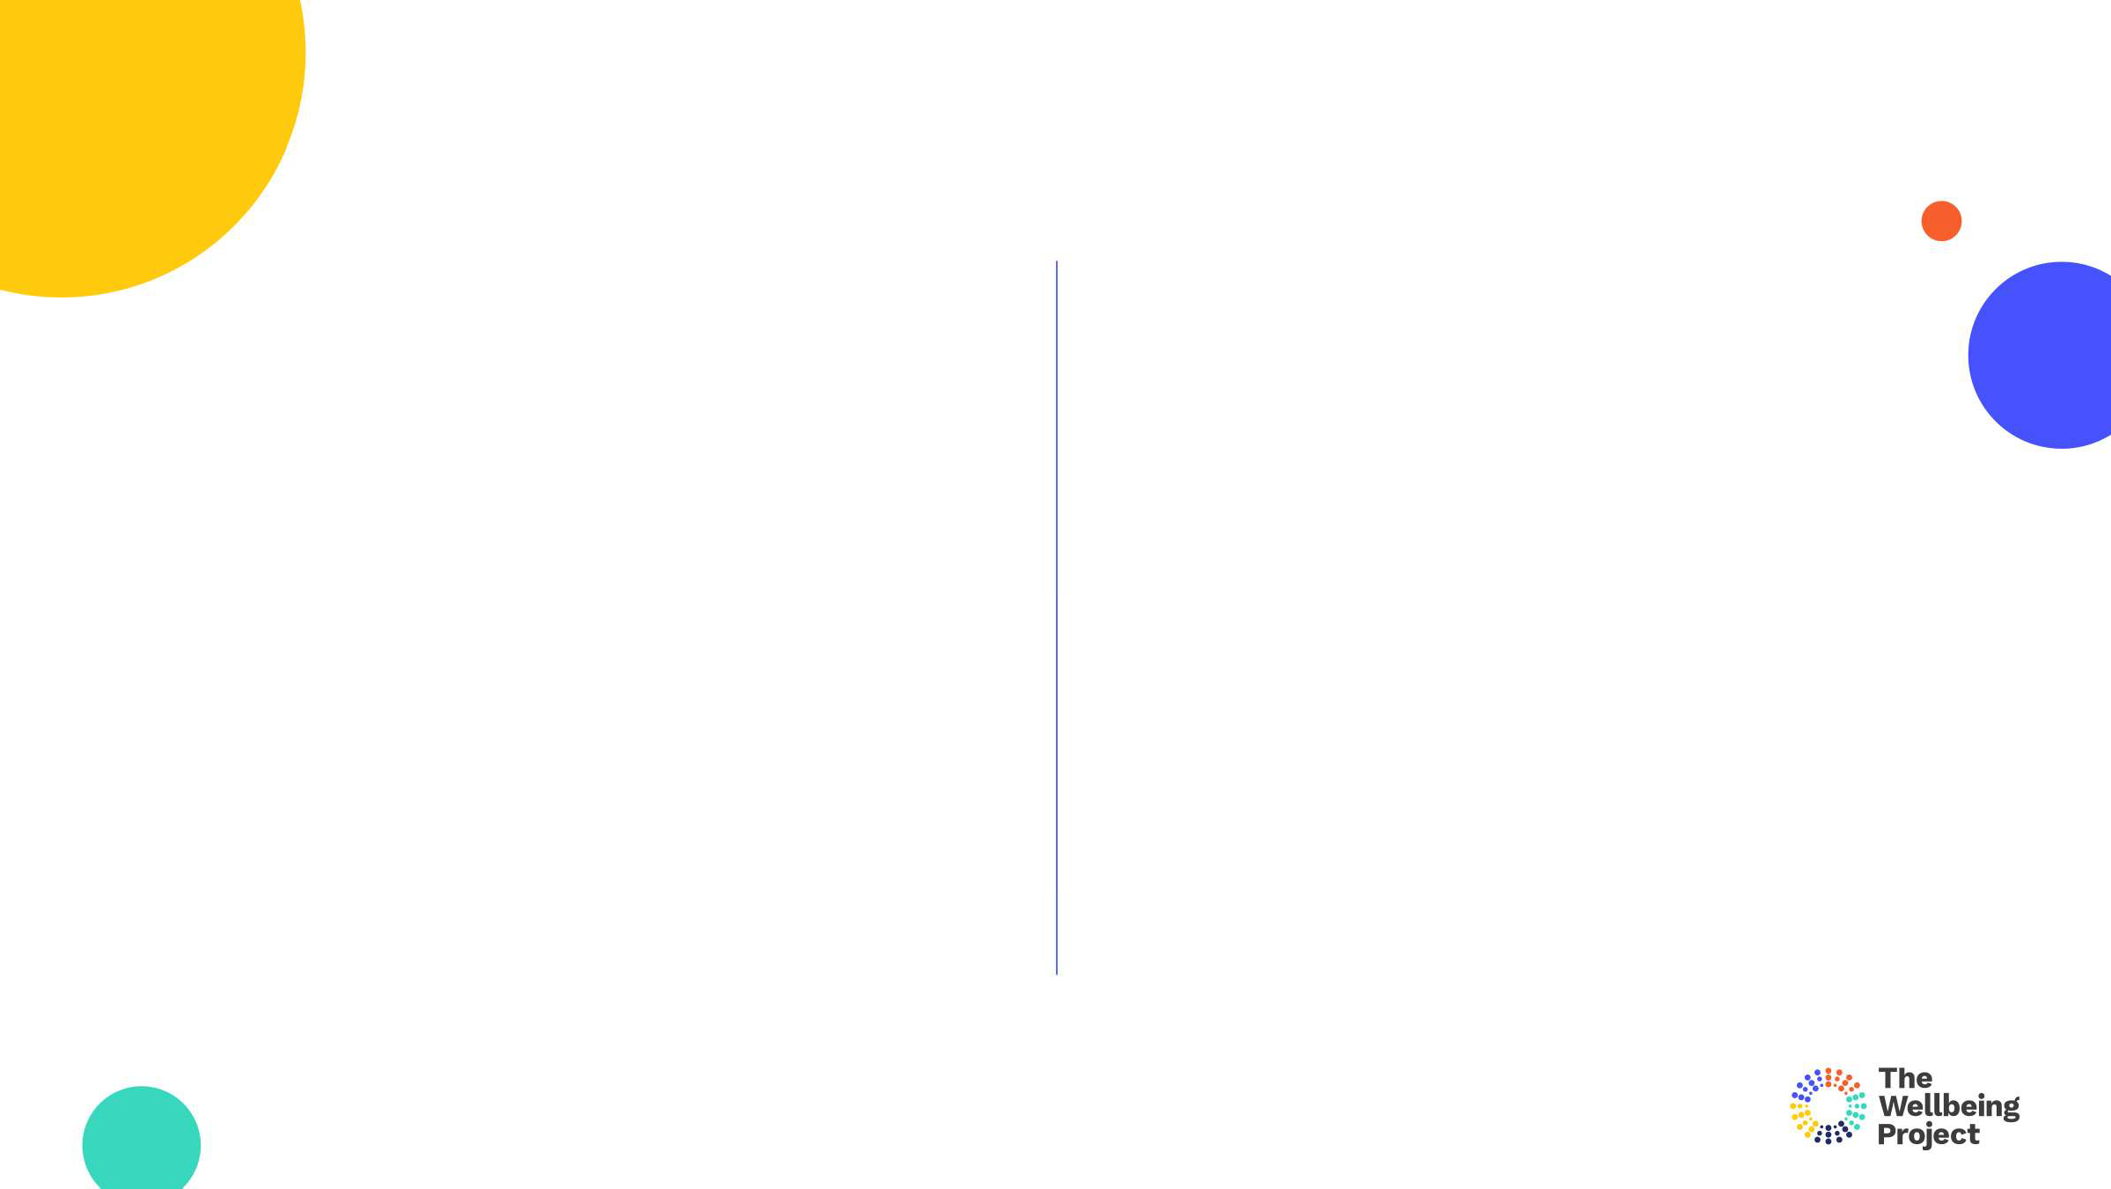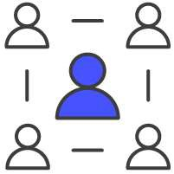

Building trust

Accessing support

* Seeking to develop trust, understanding and emotional awareness with others
* Sharing what you are going through and being prepared to access support

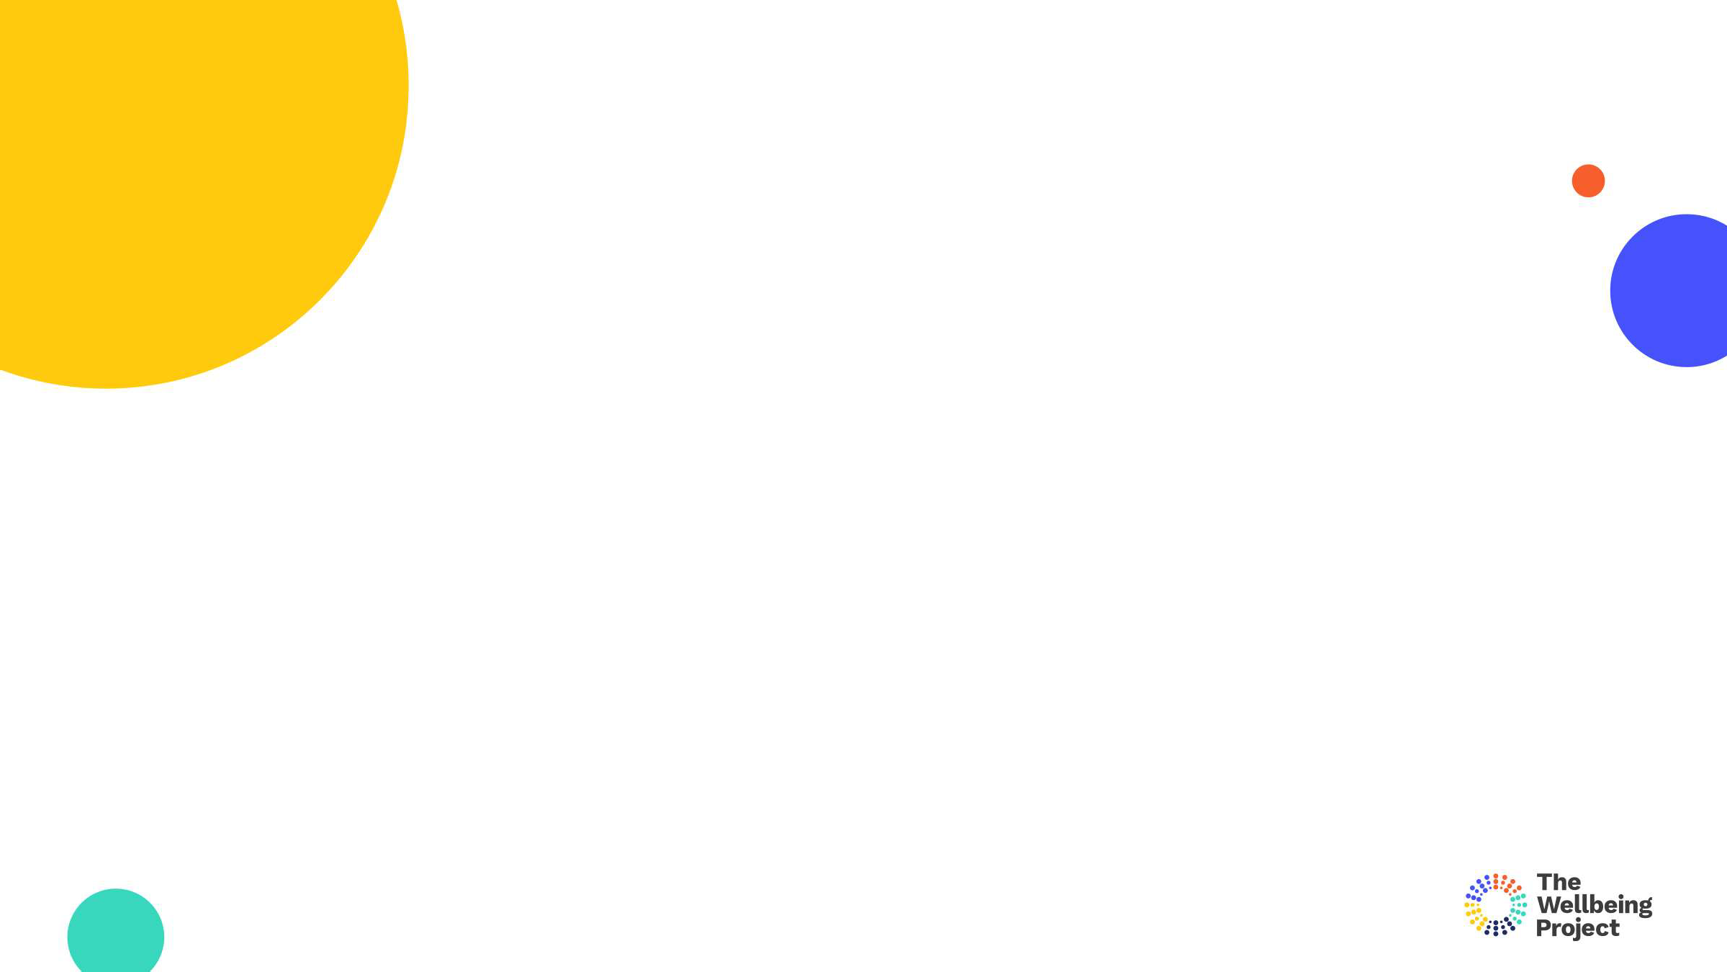

The yellow zone

* How can you ensure you access yellow both at work and at home?
* When time is short what will help you switch off and reset?

Copyright The Wellbeing Project 2021

23



6. Aspects of Strong Relationships

24 Copyright The Wellbeing Project 2021

24

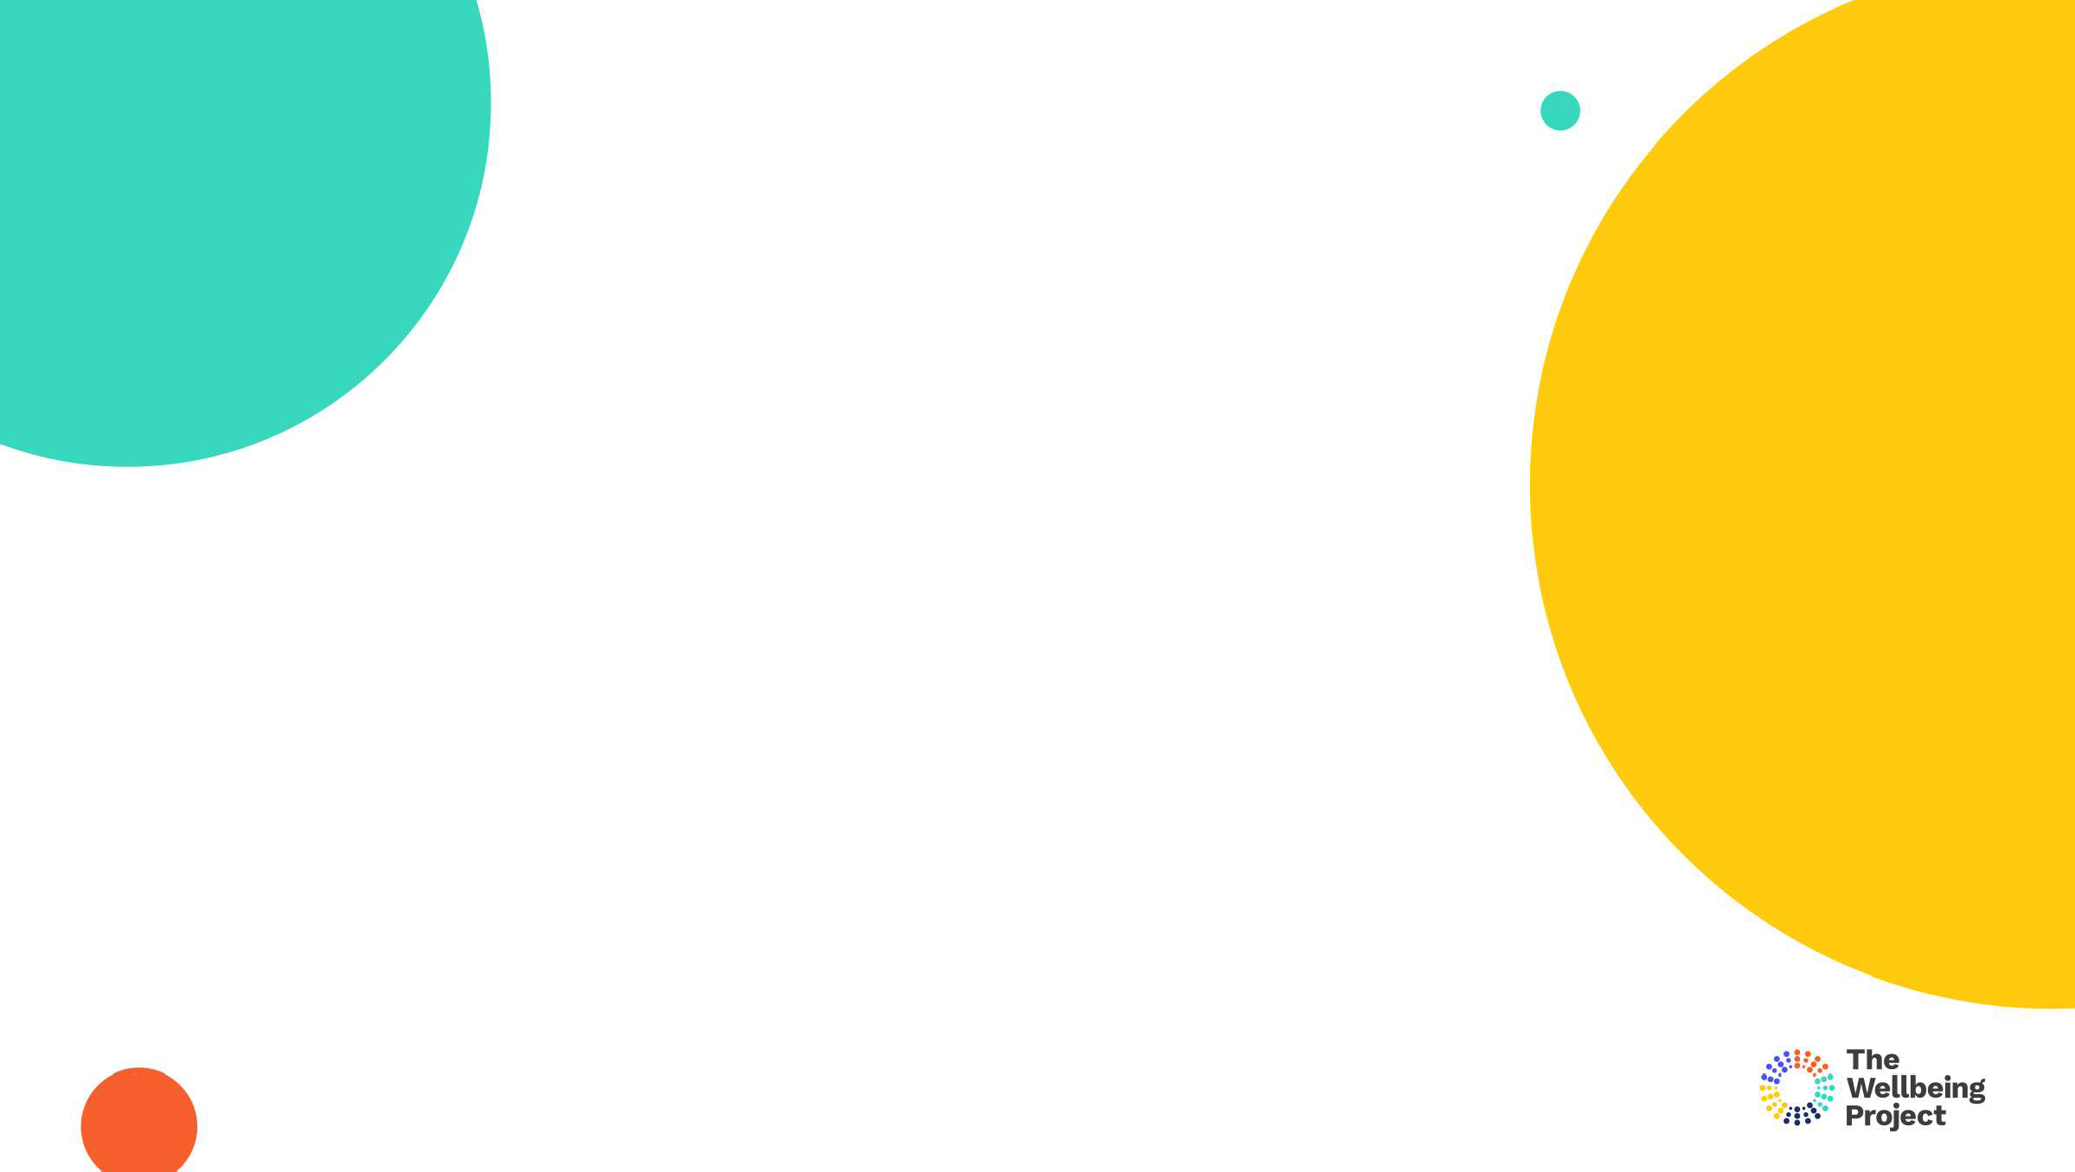

Your support network

* Where might you need more support currently?
* How will you ensure you get it?



Support networks

**FAMILY MEMBERS**

**PARTNER**

**FRIENDS**

**SUPPORT WITH PRACTICALITIES**

YOU

**COLLEAGUES**

**SPONSORS AT WORK**

**IMMEDIATE TEAM**

Copyright The Wellbeing Project 2021

26

**MUM**

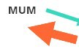

**LING**

**AARON**

YOU

**ROSIE**

**KATY**

**SANDEEP**

Copyright The Wellbeing Project 2021

27

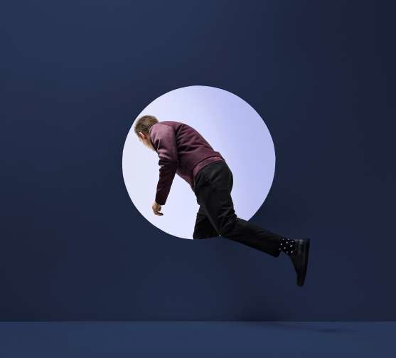

Next steps

* What 3 actions are you ready to commit to?
* What support might you need?



Copyright The Wellbeing Project 2021

29

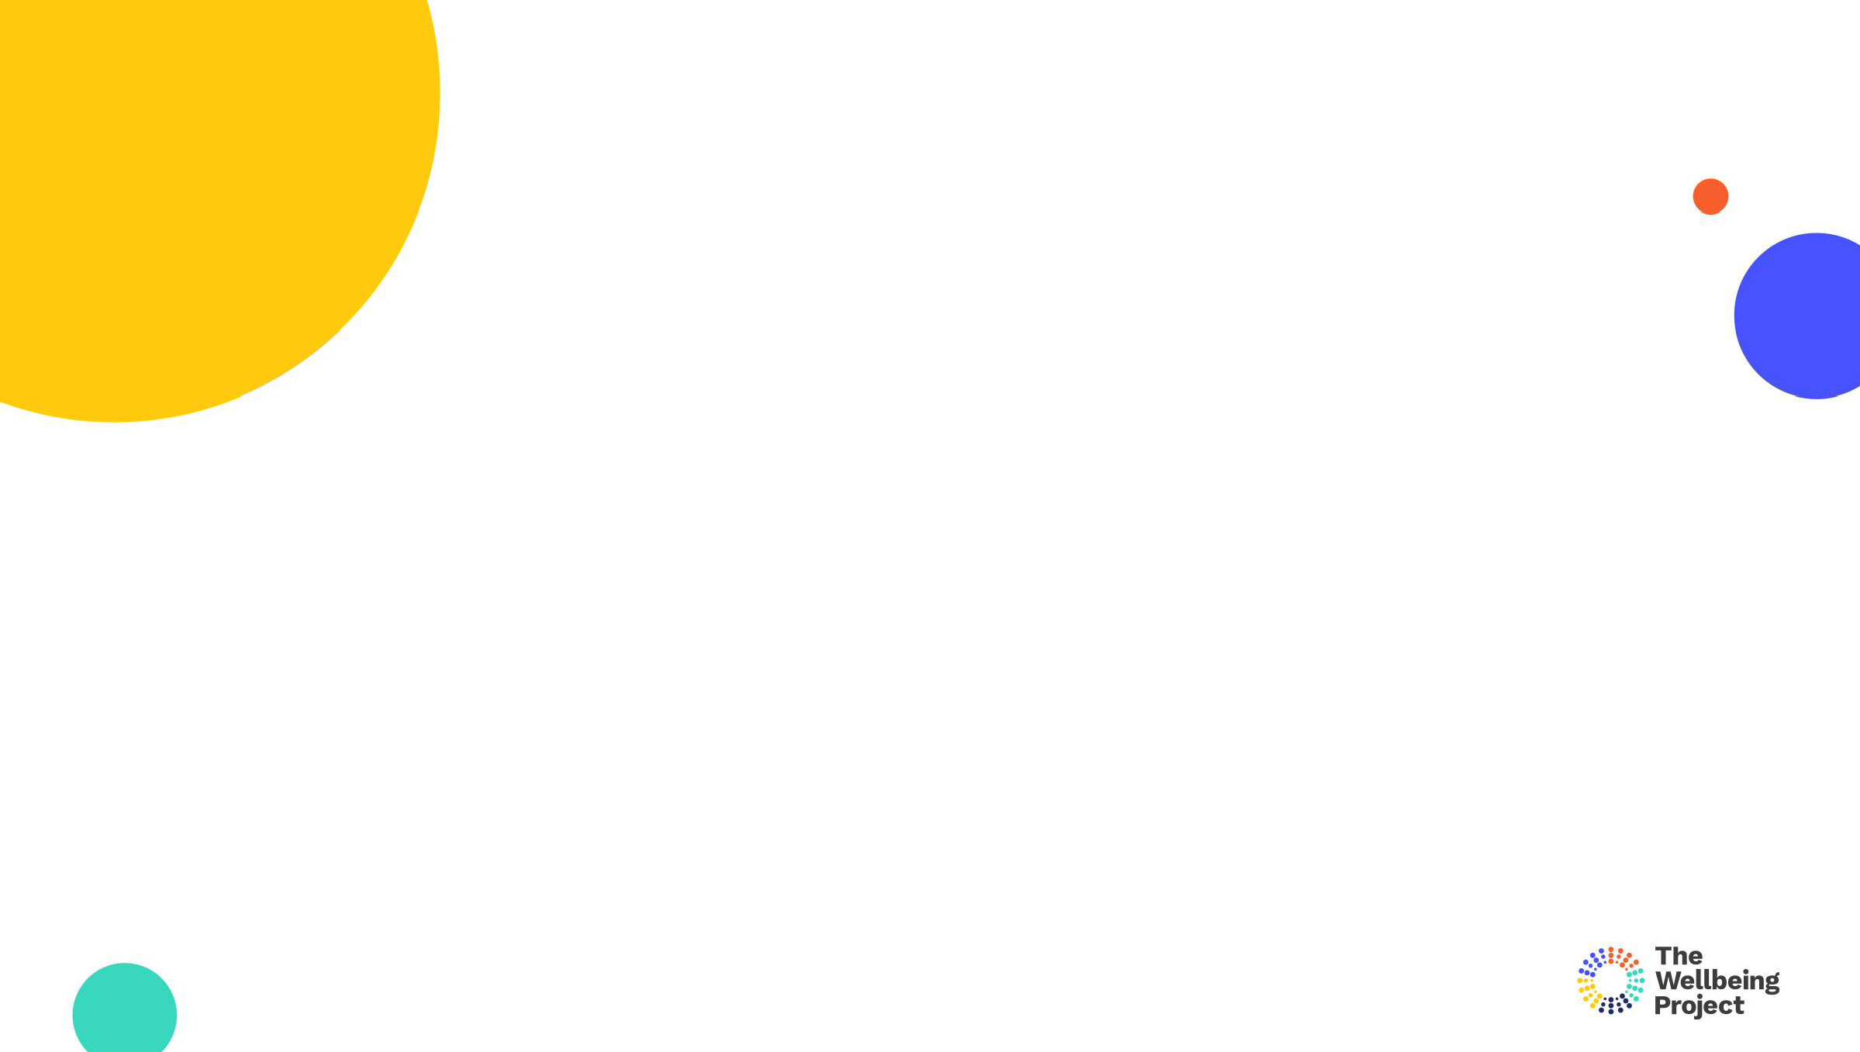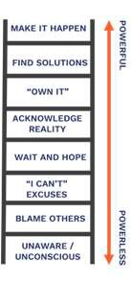

Accountability

* Where will you choose to stand on the ladder of accountability?

Copyright The Wellbeing Project 2021

30



Thank you

Disclaimer

All workshop and handout content is provided for general information purposes only and should not be treated as a substitute for the medical/financial advice of your own doctor/financial advisor, any other health care/financial professional. The Wellbeing Project uses its best efforts to ensure the accuracy and reliability of all its information. However, no guarantees are made and it cannot accept any liability for the accuracy or content used therein. Users who rely on this information do so at their own risk.

Copyright The Wellbeing Project 2021

32