The GROW Coaching Model

The GROW model is commonly used in coaching conversations and stands for:
- Goals,
- Reality,
- Options,
- What/Will/Wrap Up
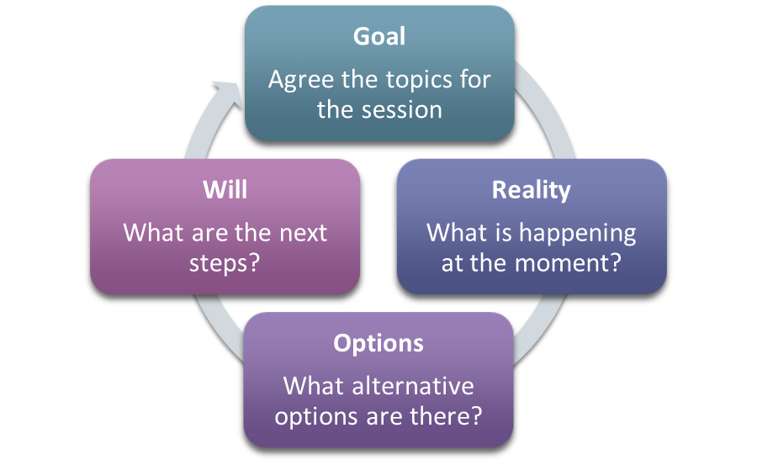
GOAL – what is your goal? What do you want to achieve? How do you want things to be different? How will you know when you have reached your goal?

REALITY – Use questions that start with what, when, where, who, how? What is happening at the moment? What is the reality of this situation? What’s working? What are the barriers or obstacles? What are your strengths/weaknesses? What have you tried? What effect is this having?

OPTIONS – What options do you have? What are the alternatives? What else?

WHAT/WILL – what are the next steps? Which options are you going to take forward? What support do you need to achieve the next steps?

