Listening Skills

There are different levels of listening and most of us are not fully listening most of the time. A good coach will have or develop the ability to listen actively.

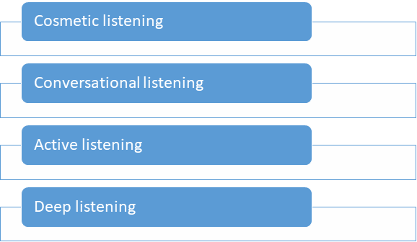

Cosmetic Listening - Essentially you are pretending to listen and not really engaged your mind might be elsewhere, e.g. you join a group of people at a conference who you don’t know very well

Conversational Listening –You are engaged and are moving between listening, talking, thinking, talking, thinking etc. Whilst the other person is talking you are often thinking about what you are going to say next.

Active Listening–an effective coach must develop ability to listen actively. To do this you must:

- Stay focused on person to fully understand them
- More effort to listen and process than speak
- Registering and recording facts to potentially return to later
- Regularly confirm listening with gestures and noises
- Actively seek clarification – reflection, summarising, repeating

Deep Listening– this is the next level of listening and you are totally lucid and present. Your focus is entirely on the other person and your mind is quiet and calm. It is in this mode of listening that we pick up on more intuitive insights, such as something that isn’t being said, or body language.

