Festschrift for David Cranston

Saturday 10th November 2018
From 12:30pm
At the Richard Doll Lecture theatre Old Road Campus

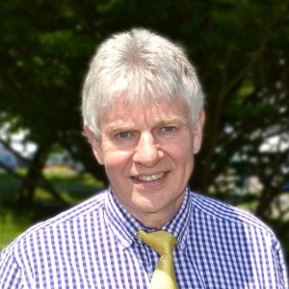

Chair Professor Freddie Hamdy

1.15
Introduction
Freddie Hamdy
Nuffield Professor of Surgery

1.20
Rocks and Snow
Bruce George
Consultant Colorectal Surgeon Oxford

1.40
Renal Autotransplantation
Rob Ritchie
Consultant Urological Surgeon Oxford

2.00
It could have been general surgery
Neil Mortensen
Vice President Royal College of Surgeons of England

2.20
Transplantation
Peter Friend
Professor of Transplantation Oxford

2.40
20 years of research collaboration
Adrian Harris
Professor of Medical Oncology Oxford

3-3.30 Tea

Chair Professor Andy Carr

3.30
From Student to Consultant
Kevin Turner
Consultant Urological Surgeon Bournemouth

3.50
Five Way that Oxford has left its mark on me!
Tim O’Brien
Vice President British Association of Urological Surgeons

4.20
The Story of High Intensity Focused Ultrasound
Gail ter Haar
Head of Therapeutic Ultrasound Institute of Cancer Research

4.40
Some Great Physicians
James Kennedy
Team Rector Chipping Norton Church

5
Chinese Collaboration
Zhibiao Wang
Director National Engineering Research Centre of Ultrasound Medicine in China

5.20
Anaesthetic Challenges in Dinosaurs
Jonathan Cranston
Veterinary advisor to Jurassic World –Fallen Kingdom

Dinner at Balliol

7.30 for 8
Black Tie

Grace: Rev Dr James Kennedy

Speakers: Professor Peter Morris
Mr John Reynard

